# PF Assignment01:

## PAC:-

|  |  |
| --- | --- |
| **Given Data** | **Required Results** |
| • X coordinate • Y coordinate | The location of the point (Quadrant I–IV, on an axis, or at the origin) |
| **Processing Required** | **Solution Alternative** |
| * If x>0 and y>0 → Quadrant I * If x<0 and y>0 → Quadrant II * If x<0 and y<0 → Quadrant III * If x>0 and y<0 → Quadrant IV * If x=0 and y != 0 or y=0 → On y-axis * If y=0 and x!=0 orx=0 → On x-axis * If x=0 and y=0 → Origin | * Use nested if/else conditions * Use repetition (loop) if processing multiple points. |

## IPO:-

|  |  |  |  |
| --- | --- | --- | --- |
| **Input** | **Processing** | **Module Reference** | **Output** |
| x, y values      x, y values | Check signs of x and y    Check if point lies on axes (x=0 or y=0) | Quadrant check module      Axis or origin check module | Quadrant (I-IV)        Axis or origin |

## IC CHART

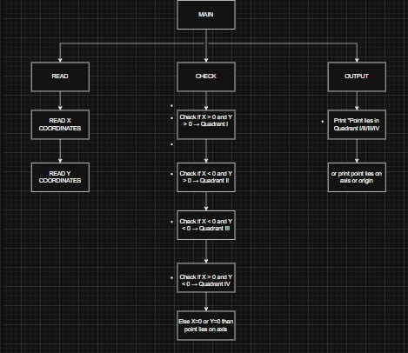

## ALGORITHM

1. Start
2. Input values of x and y.
3. If x>0 and y>0 → Quadrant I 4. Else If x<0 and y>0 → Quadrant II 5. Else If x<0 and y<0 → Quadrant III 6. Else If x>0 and y<0 → Quadrant IV
4. Else If x=0 and y != 0 or y=0 → On y-axis
5. Else If y=0 and x!=0 orx=0 → On x-axis 9. If x=0 and y=0 → Origin

10. END

## PSEUDO CODE

Start

Input x, y

If x>0 and y>0

Then print “Quadrant I”

Else If x<0 and y>0

Then print “Quadrant II”

Else If x<0 and y<0

Then print “Quadrant III”

Else If x>0 and y<0

Then print “Quadrant IV”

Else If x=0 and y != 0 or y=0

Then print “On y-axis"

Else If y=0 and x!=0 or x=0

Then print “On x-axis"

If x=0 and y=0

### Then print “Origin”

## FLOW CHART

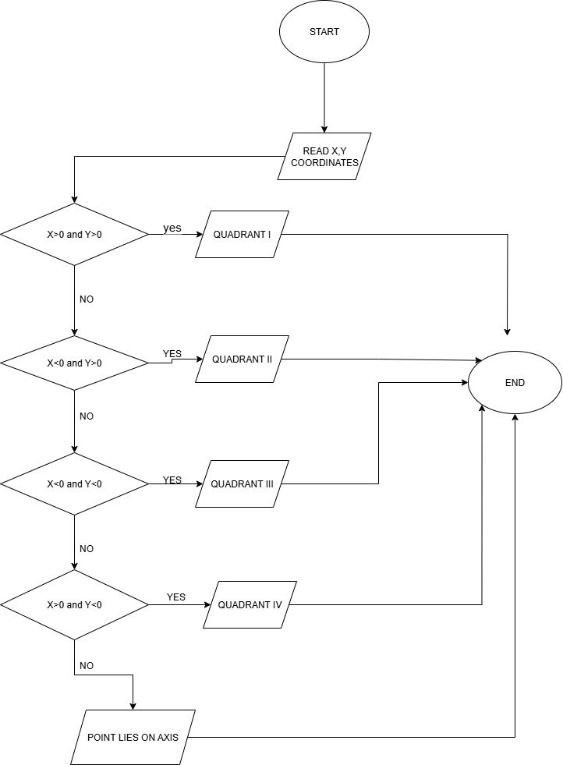

## C CODE

